Vilvesh Srinivasan

COSC 2436

6/15/2017

Elements vs Execution Time for Quick Sort and Bubble Sort Algorithm

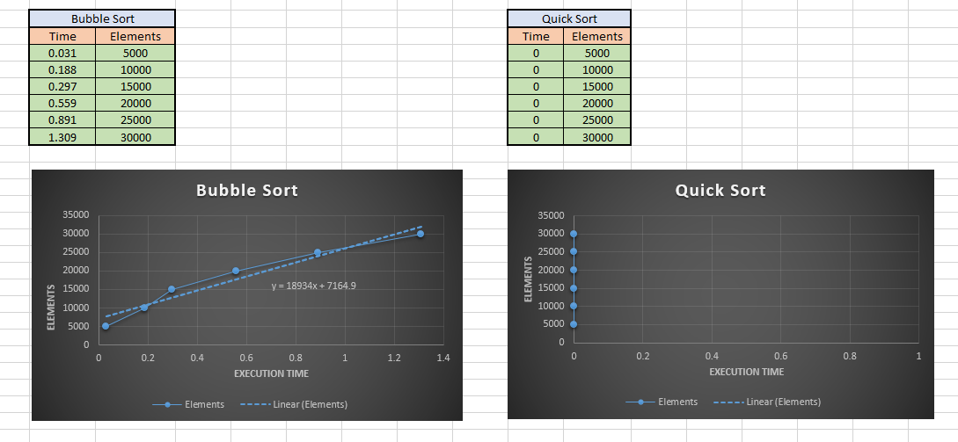

x = 0

**Conclusion:**

Quick Sort is a lot faster than Bubble Sort!